|  |  |  |
| --- | --- | --- |
|  | **Project Design Phase-II** | |
|  | **Technology Stack (Architecture & Stack)** | |
|  |  |  |
| Date |  | 16 October 2022 |
|  |  |  |
| Team ID |  | PNT2022TMID31216 |
|  |  |  |
| Project Name |  | Emerging method for Early Detection |
|  |  | of Forest Fires |
|  |  |  |
| Maximum Marks |  | 4 Marks |
|  |  |  |

**Technical Architecture:**

The Deliverable shall include the architectural diagram as below and the information as per the table1 & table 2

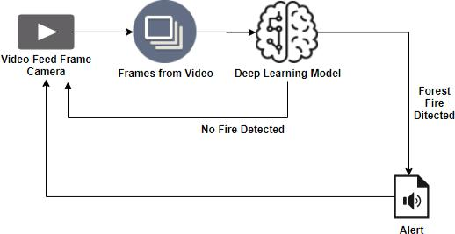

**Table-1 : Components & Technologies:**

|  |  |  |  |
| --- | --- | --- | --- |
| **S.No** | **Component** | **Description** | **Technology** |
|  |  |  |  |
| 1. | User Interface | How user interacts with application e.g. Mobile App, | HTML, CSS, JavaScript / Angular Js / |
|  |  | database system | React Js etc. |
|  |  |  |  |
| 2. | Application Logic-1 | Logic for a process in the application | Java / Python |
|  |  |  |  |
| 3. | Camera | Logic for a process in the application | FPV Camera technology |
|  |  |  |  |
| 4. | Smoke sensor | Logic for a process in the application | MQZ, etct |
|  |  |  |  |
| 5. | Database | Data Type, Configurations etc. | MySQL, NoSQL, etc. |
|  |  |  |  |
| 6. | Cloud Database | Database Service on Cloud | IBM DB2, IBM Cloudant etc. |
|  |  |  |  |
| 7. | database system | File storage requirements | Other Storage Service or Local |
|  |  |  | Filesystem |
|  |  |  |  |
| 8. | Rotary--wing UAV | Purpose of firefighting used in the application | IBM Weather API, etc. |
|  |  |  |  |
| 9. | EFixed--wing UAV | Purpose of weather monitoring.used in the | Aadhar API, etc. |
|  |  | application |  |
|  |  |  |  |
| 10. | Machine Learning Model | Purpose of Machine Learning Model | Object Recognition Model, etc. |
|  |  |  |  |
| 11. | Infrastructure (Server / Cloud) | Application Deployment on Local System / Cloud | Local, Cloud Foundry, Kubernetes, etc. |
|  |  | Local Server Configuration: |  |
|  |  |  |  |

Cloud Server Configuration :

**Table-2: Application Characteristics:**

|  |  |  |  |
| --- | --- | --- | --- |
| **S.No** | **Characteristics** | **Description** | **Technology** |
|  |  |  |  |
| 1. | Open-Source Frameworks | List the open-source frameworks used | Technology of Opensource framework |
|  |  |  |  |
| 2. | Security Implementations | List all the security / access controls implemented, | e.g. SHA-256, Encryptions, IAM Controls, |
|  |  | use of firewalls etc. | OWASP etc. |
|  |  |  |  |
| 3. | Scalable Architecture | Justify the scalability of architecture (3 – tier, Micro- | Technology used |
|  |  | services) |  |
|  |  |  |  |
| 4. | Availability | Justify the availability of application (e.g. use of load | Technology used |
|  |  | balancers, distributed servers etc.) |  |
|  |  |  |  |
| 5. | Performance | Design consideration for the performance of the | Technology used |
|  |  | application (number of requests per sec, use of |  |
|  |  | Cache, use of CDN’s) etc. |  |
|  |  |  |  |